

**Computer Science Final-Year Project**

**Ethics Application Form 2019-20**

**Applicant details**

|  |  |
| --- | --- |
| **Project title** | **Detecting Political Bias in Text** |
| **Name of final-year project student** | **Richard Jones** |
| **Keele e-mail address of student** | **w8a76@students.keele.ac.uk** |
| **Name of project supervisor** | **Dr. Charles Day** |

**Project Summary**

|  |
| --- |
| Provide a short summary of your project **(max 250 words).**  The project will focus around the design of a system that can process a . For each article, the system will use sentiment analysis (most likely through a Long-Short Term Memory NN) in an attempt to detect opinionated bias towards their contents, assigning a single value based on the article’s overall political bias.  The output of the system will be recorded in a database for later querying, and an interface will be constructed around the system for a user to interact with the Neural Network. |

|  |
| --- |
| In simple terms, provide a *short* description of your planned experimental method that involves participants (e.g., focus groups, questionnaires, interviews, experimental observations).   * A User-Testing session will be carried out for each participant, where each user will be asked to carry out specific tasks on the developed software while ‘thinking aloud’ |

|  |
| --- |
| Describe the characteristics of your participants, and any inclusion or exclusion criteria. Estimate the approximate number of participants.  All participants will be students or staff of the School of Keele University.  Approximately,15-20 participants will be recruited for the User-Testing and Questionnaire |

**Recruitment and Consent**

|  |
| --- |
| Indicate how potential participants will be identified, approached and recruited and outline any relationship between the researcher and potential participants.  Students and staff will be invited in person or via email with the following invitation:  *You are invited to participate in a study for a final-year project entitled: Design of School Web Pages.*  *Participation will involve approximately one hour of your time for one 40-minute focus group discussion about School web pages and 20 minutes of individual testing. These activities will be scheduled according to your availability. If you are interested in participating, please read the Information Sheet.* |

|  |
| --- |
| Describe the process that will be used to seek and obtain informed consent.  If individuals express an interest in participating they will be provided with an Information Sheet (printed or electronic). If they are happy to proceed they will be asked to sign the Consent Form before participating. |

|  |
| --- |
| Will consent be sought to use the data for other research? Yes  No  Will consent be sought to contact the individual to participate in future research? Yes  No |

|  |
| --- |
| Can participants withdraw from the research? Yes  No  **If yes**, state up to what point participants are able to withdraw from the research  Participants will be allowed to withdrawal from the research  **If yes**, outline how participants will be informed of their right to withdraw, how they can do this and what will happen to their data if they withdraw.  Contact information for withdrawal is provided on the Participant Information Sheet.  **If no**, explain why they cannot withdraw (e.g., anonymous survey). |

**Confidentiality and anonymity**

|  |
| --- |
| Outline the procedures that will be used to protect, as far as possible, the anonymity of participants and/or confidentiality of data during the conduct of the research and in the release of its findings.  All participant names will be replaced by codes, for example, P01, P02, P03, etc. No names (or other information that might reveal participant identity) will be included in the project dissertation or in any other presentation. |

**Storage, access to, management of, and disposal of data**

|  |
| --- |
| Describe how participant data will be stored; where it will be stored and for how long; and how/when it will be disposed of.  All participant data will be securely stored until the end of the project. All electronic records will be stored on university drives. Only the applicant (student investigator) and supervisor will have access to participant data. At the end of the project the participant data will be deleted. |

**Other ethical issues raised by the research**

|  |
| --- |
| Are there any other ethical issues that may be raised by the research? Yes  No  If yes, please give details. |

**Declarations**

|  |
| --- |
| **Declaration by student**  I confirm that:   * The form is accurate to the best of my knowledge. * I will inform my supervisor and resubmit an ethical application if there are any changes to the project. * I am aware of my responsibility to comply with the requirements of the law and any relevant professional guidelines. |
| Student name Richard Jones |
| Student signature |
| Date 19/12/19 |

|  |
| --- |
| **Declaration by supervisor**  I confirm that:   * I have read the application and am happy for it to proceed for ethical review. * The application is accurate to the best of my knowledge. * I am aware of my responsibility to ensure that the applicant is familiar with and complies with the requirements of the law and any relevant professional guidelines. |
| Supervisor name |
| Supervisor signature |
| Date |



**Participant Information Sheet**

**Study Title**: Design of School Web Pages

**Aims of the Study**

The aim of the study is to create a new improved design for the School Web Pages.

**Invitation**

You are being invited to consider taking part in the study: **Design of School Web Pages***.* This project is being undertaken by **Student One**.

Before you decide whether or not you wish to take part, it is important for you to understand why this study is being done and what it will involve. Please take time to read this information carefully and discuss it with friends and relatives if you wish. Ask us if there is anything that is unclear or if you would like more information.

**Why have I been invited?**

As a student or member of staff of the School of Computing and Mathematics you are eligible to participate.

**Do I have to take part?**

You are free to decide whether you wish to take part or not. If you do decide to participate you will be free to stop participating at any time and you can remove your data up to one week after participating without giving reasons.

**What will happen if I take part?**

You will be asked to join a focus group discussion with 3-5 students and/or staff to discuss the current School web pages and share opinions about designs for new School web pages. This will take approximately 40 minutes. This will be scheduled according to your availability and the availability of other participants.

At a future time you will be asked to perform test use of the current and new web pages and complete a short questionnaire. This will take approximately 20 minutes.

Both the focus group discussion and web page test use will be audio recorded for the purposes of annotation.

**What are the benefits (if any) of taking part?**

You will have the opportunity to input to a new design proposal that could contribute to future web page designs. Additionally, student participants may find the experience of participating helps inform their ideas for their own current or future project.

**What are the risks (if any) of taking part?**

No risks have been identified for this participation.

**How will information about me be used?**

The focus group discussion and test web page use will be audio recorded. These recordings will be stored securely in a university file space and will be deleted at the end of the project. Annotations made from the recordings will be compiled and analysed, and reported in the dissertation. The recording will not be used for any other purposes.

Completed consent forms will be retained securely until the end of the project when they will be destroyed. (Completed consent forms will not be included in the project dissertation).

Completed questionnaire results will be anonymised (names replaced with participant codenames) and this anonymised data will be reported in the dissertation.

If permission if given to use quotes, these quotes may be reported in the project results and the dissertation.

**Who will have access to information about me?**

Your data will be stored securely until the end of the project. All electronic records will be stored on university drives. Only myself (student) and supervisor will have access to your data.

At the end of the project your data will be deleted.

**What if there is a problem?**

If you have a concern about any aspect of this study, you may wish to speak to me (the student investigator) or my supervisor. We will do our best to answer your questions. Our contact details are:

Student One, [studentoneemail@keele.ac.uk](mailto:studentoneemail@keele.ac.uk) & Supervisor One,supervisoroneemail@keele.ac.uk

**Contact for further information and withdrawal**

If you would like withdraw your data from the study, please contact:

Student One, [studentoneemail@keele.ac.uk](mailto:studentoneemail@keele.ac.uk)



**CONSENT FORM**

**Title of Project:** Design of School Web Pages

**Name and contact details of student investigator and supervisor:**

Student One, [studentoneemail@keele.ac.uk](mailto:studentoneemail@keele.ac.uk) & Supervisor One, supervisoroneemail@keele.ac.uk

## Please tick box if you

## agree with the statement

1. I confirm that I have read and understood the Participant Information Sheet and have had the opportunity to ask questions.
2. I understand that my participation is voluntary and that I can stop participating at any time and can withdraw my data up to one week after participation without giving a reason.
3. I agree to take part in this study.
4. I understand that data collected about me during this study will be anonymised before it is reported in any reported results.
5. I agree to audio recording of the focus group and testing.

|  |  |  |
| --- | --- | --- |
| _______________________ Name of participant | __________________ Date | ____________________ Signature |
| _______________________  Student investigator | __________________ Date | ___________________ Signature |



**CONSENT FORM**

**(for use of quotes)**

**Title of Project:** Design of School Web Pages

**Name and contact details of student investigator and supervisor:**

Student One, [studentoneemail@keele.ac.uk](mailto:studentoneemail@keele.ac.uk) & Supervisor One, supervisoroneemail@keele.ac.uk

## Please initial box if you

## agree with the statement

1. I agree for my quotes to be used
2. I do not agree for my quotes to be used

**FOCUS GROUP DISCUSSION THEMES**

The focus group discussion themes are as follows:

1. Current and previous use of the School web pages (and similar web pages)
2. Opinions about the content and structure of the current web pages
3. Opinions about new designs

**SYSTEM USABILITY SCALE QUESTIONNAIRE**

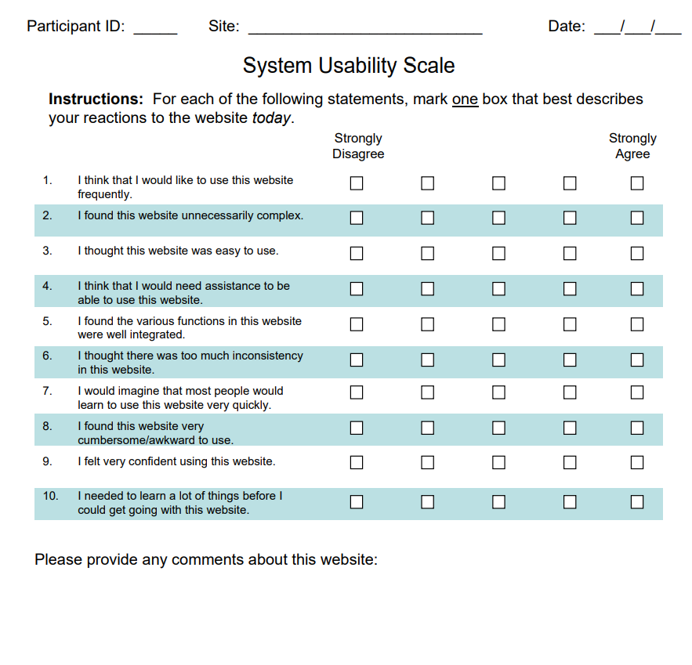

<https://www.measuringux.com/SUS.pdf>